**Research Article**

**Ac-227 Dose of Accelerator Generated Ac-225 in Mice**

Andrew L. Lakes 1, Dahlia D. An 1, Julian A. Rees 1, Rebecca J. Abergel 1,2

1 Chemical Sciences Division, Lawrence Berkeley National Laboratory, Berkeley, CA 94720

3 Department of Nuclear Engineering, University of California Berkeley, Berkeley, CA 94709

**Corresponding author:** Rebecca J. Abergel. [rjabergel@lbl.gov](mailto:rjabergel@lbl.gov).

**First author:** Andrew L. Lakes. [andrewllakes@gmail.com](mailto:andrewllakes@gmail.com).

**Words:** xxxx. **Figures**: xxxx. **Tables**: xxxx. **References:** xxxx

**Financial:** This work was supported by

**Running title:**

**Keywords:**

**Abstract:**

Production something

With three different Ac-225 constructs, we model the worst case scenario future dose rate for Ac-227 contamination in Ac-225 doses in mice out to one Ac-227 half life, 21.77 years.

**INTRODUCTION**

1) Ac-225 isotope production

2) Ac-227 decay properties compared to Ac-225Ac-225 decays rapidly after the initial 9.9 day alpha decay into Fr-221, with a 45.5 minute pause for the half-life of Bi-213.

After this pause, there remains only 1 alpha decay (Po-213), accounting for 30% of the total alpha energy released. The Ac-227 decay chain begins with a low energy beta decay over a lengthy 7946 days, resulting in the therapeutically relevant Th-227.

The Th-227 alpha decays into Ra-223 after 18 days. After the 11.43 day alpha decay from Ra-223 intoRn-219, the remaining daughters decay with rapidity other than the 36 minute half-life of Pb-211, resulting in a final tally of 5 alpha and 3 beta decays. After Pb-211 pause, there remains only 1 alpha decay (Bi-211), accounting for 20% of the total energy released. The total energy released during the Ac-227 decay chain is approximately 20% greater than the Ac-225 chain.

3) study set up / why

Materials tested -> can cite tastuzumab-Ac-225 literature

3) Long term dose effect of Ac-227

**MATERIALS AND METHODS**

**Materials**

3,4,3-LI(1,2-HOPO), referred to as HOPO, was XXXXXpurchased or synthesized?XXXXXXX. IgG1 antibody was purchased from Sigma-Aldrich. Trastuzumab was XXXdonated or purchased?XXXXXXX. 1,4,7,10-Tetraazacyclododecane-1,4,7-tris-acetic acid-10-maleimidoethylacetamide (DOTA-MMA) was purchased from Macrocyclics, Bradford reagent was purchased from Bio-rad, and tris(2-carboxyethyl)phosphine hydrochloride (TCEP HCl), L-glutathione reduced, and all other chemicals were purchased from Sigma-Aldrich.

**Activity counting**

All activity was counted with a Perkin-Elmer Tri-Carb 2910 TR. Dilutions of radiolabeled solution activity for injection were diluted with 10 mL of Ultima Gold LLT scintillation cocktail. For biodistribution, samples were ashed in a furnace, dissolved in nitric acid, and diluted into 10 mL Ultima Gold LLT scintillation cocktail.

**Radiolabeling**

*Caution: Lu-177 and Ac-225 are radioactive isotopes that may present serious health risks when incorporated. Experiments were performed in facilities specially designed for the safe-handling of radioactive materials at the Lawrence Berkeley National Laboratory (LBNL).*

For DOTA and HOPO radiolabeling sans antibody, a dry heating block was used to heat ligands to 60 ºC for 2 hours in pH 7.4 10 mM phosphate buffered saline (PBS) at 200:1 excess Ligand:Metal. For antibodies-DOTA conjugates, a dry heating block was warmed to 45 ºC and antibody-DOTA conjugates (cysteine sites) were pre-incubated for 5 minutes, dissolved in 0.1M pH 5.4 ammonium acetate. Radionuclide in 0.05N HCl was added at 200x excess Ligand:Metal for 2 hours. Starting activity was based on an aliquot of the stock solution at equilibrium upon radiolabeling. These radiolabeled solutions were washed and buffer exchanged (10x volume 5 times) into PBS of pH 7.4, and aliquots of filtrate and retentate were taken for final activity and yield verification.

**Animal Handling**

All procedures and protocols used in the described *in vivo* studies were reviewed and approved by the LBNL Institutional Animal Care and Use Committee (IACUC) and were performed in AAALAC accredited facilities.

**Animal Injection**

Contamination is achieved by intravenous injection in a warmed lateral tail vein of the challenge chelated isotope. Animals are housed in metabolism cages, per randomization group (n = 3). Urine and fecal pellets are collected daily until necropsy. Blood, liver, kidneys, spleen, heart, lungs, thymus, abdominal remainder tissue (ART), skeleton, and soft tissue remainder samples collected at scheduled necropsy and processed for analysis. Counting is done on a gamma counter and on an alpha/beta LSC counter. Samples are counted promptly after processing and repeatedly over 100 days to allow for equilibration of Ac-227 daughter products.

**Biodistribution**

Biodistribution results are reported as percent recovered dose per mass (%RD/g) as excreta was collected alongside the organs and tissues. xxxxxxxxxxxxxxxxxx

**Dose Modeling**

Utilizing the kinetic dose results, we created an estimated future dose for DOTA-Ac, Trastuzumab-DOTA-Ac, and HOPO-Ac control (see supplemental) accelerator-generated actinium constructs. The input dose bolus was 200 nCi for Ac-225 and 1 nCi for Ac-227 (0.5% Ac-227 contamination), and assumed to be pure actinium without daughters (all activity is only actinium at time = 0 of the injection). Dose modeling was performed across two regimes: 1) interpolation within the actual recorded data set (0-10 days), and 2) extrapolation of future dose assuming no further change in final time point. Between real recorded time point values of 1 hr, 4 hr, 24 hr, 4 days, 6 days (and 10 days for Trastuzumab-DOTA only), small step changes were added for interpolation. Numerically solving the standard Bateman ordinary differential equations produced an activity per time correlation. Next, using the energy output for each decay along the daughter series’, a moving average of power per count of activity (MeV/minute / CPM) for each time step was found, to get MeV/count. 100% efficiency of counting was assumed per decay. For time points within the real recorded time points, a monotonic cubic spline was used to gather activities, where activity past the real data assumes no change in biodistribution, and only decay occurs (see **Figure Sxxx**). Power per mass (MeV/(g*day)) was found per time step based on organ masses, and was numerically integrated to convert to energy per mass for conversion into units of Grey. Unequal variance standard deviation was also modeled via cubic spline interpolation and numerical integration for real data points with error propagation, and 95% confidence intervals were determined via assuming n=5 for each future time point beyond the real data of n=5. To determine the time of unity for Ac-227/Ac-225 ratios for dose per day, an exponential fit was used, and for cumulative dose a linear fit was used. Each organ/tissue point of unity was determined from a cubic spline interpretation, along with the error.

**RESULTS --------🡪 update figure letters and numbers!**

After injection of 2 nCi/g of Ac-225 construct with up to 0.5% Ac-227 contaminant to either 1) female Swiss-Webster mice with DOTA-Ac or HOPO-Ac control, or 2) female NOD SCID PDX mice with Trastuzumab-DOTA-Ac, biodistribution of Ac-225 and Ac-227 was investigated over several time points. DOTA was used as the ligand for actinium due to its *in vivo* stability and commercial availability as a bifunctional chelator (cite Robertsom curr radiopharm 2015 - Development of 225Ac Radiopharmaceuticals: TRIUMF Perspectives and Experiences). Biodistribution was compared via recovered dose per gram (RD/g) or localization ratio (LR) of Ac-225/Ac-227 RD/g values to determine any distribution effects.

**Biodistribution**

*Recovered Dose per Mass*

DOTA biodistribution in healthy mice was typical with activity locating heavily in the kidneys initially compared to other organs, and rapidly dropping activity across all collected tissues due to renal clearance (**Figure 2A**). Ac-227 distribution, however, indicated lingering carcass content over 6 days, but at low content (**Figure 2B**). In NOD SCID HER2-positive patient derived xenograft mice treated with targeted Trastuzumab-DOTA-Ac, RD/g biodistribution was also typical, where blood circulation content decreased over time more slowly than DOTA-Ac due to extended circulatory half-life antibodies provide, and with increasing spleen uptake as the largest %RD/g (likely due to immune opsonization), followed by liver and tumor uptake (**Figure 2C/D**). As a control for a predominantly hepatic-based clearing system, HOPO-Ac was also tested. As anticipated in native mice, liver uptake was high for both Ac-225 and Ac-227, with lower distribution to other organs throughout 6 days after injection (**Figure S3**).

*Isotopic Localization Ratio*

Interestingly, even though both Ac-225 and Ac-227 samples were counted at secular equilibrium using the same method (liquid scintillation counting of ashed tissue samples, Ac-227 equilibrium starts at roughly 100 days, Ac-225 after roughly 13 hours), Ac-225 appears to localize differently to Ac-227 depending on the initial parent construct. LR data in **Figure 3** are based upon ratios from **Figure 2** biodistribution recovery results. Across the board for all tissues, the LR of DOTA-Ac (**Figure 2A**) shows more rapid clearance from the body of Ac-225 compared to Ac-227, with LR below 1. With Trastuzumab-DOTA-Ac (**Figure 2B**), however, the Ac-227 clears faster at longer time points for the spleen. As the blood LR increased for Ac-225, so did spleen, but with only a single significant difference at the final 10-day time point for the spleen LR (n=5, mean = 2.94 ± 1.43 SD, one-tailed P-value = 0.02 vs. unity). The 10 day time point for Trastuzumab-DOTA-Ac LR is beyond the scale due to extremely low activity in the Ac-227 biodistribution sample, and standard deviation error bars cross the abscissa indicating no significance. HOPO-Ac LR for the heart, lungs, kidneys, liver, and carcass tended to be at or greater than 1 (**Figure S4**). LR also trended a decrease from above unity in earlier time points to at or below unity in later time points for all organs except the spleen and ART. For the organ with greatest localized uptake with both isotopes, the liver, the LR at the final time point at 6 days was not statistically significant from unity.

**Dose Modeling**

After dose interpolation and extrapolation of each organ’s RD/g assuming an equal 200 nCi Ac-225 and 1 nCi Ac-227 (0.5%), output measurements of dose vs time, dose ratio (Ac-227/Ac-225) vs time, and dose/day vs time were calculated.

*DOTA-Ac*

DOTA-Ac had the greatest cumulative Ac-225 dose to the kidneys, with a dose of 0.0167 Gy (95% CI 0.0150-0.0183 Gy) at 100 days (**Figure 2E**), where Ac-227 only showed roughly 20% the dose at 0.00331 Gy (95% CI 0.00315-0.00347 Gy) (**Figure 2E**). However, the estimated Ac-227 cumulative dose continued to increase to 0.311 Gy (95% CI 0.296-0.326 Gy) after 7946 days (**Figure 2E**) for a Ac-227/Ac-225 dose ratio of roughly 20 times at 7946 days (**Figure 2F**). Compared to the kidneys, the carcass for Ac-227 showed roughly 2x higher cumulative dose. The dose per day for DOTA-Ac-225 in the kidneys showed a maximum at the initial time point of 1 hour, with 3.02E-3 Gy/day (95% CI 2.95E-3 - 3.09E-3 Gy/day) (**Figure 3C**), with a DOTA-Ac-227 maximum at 200 days with only 5.35E-5 Gy/day (95% CI 5.09E-5 – 5.60E-5 Gy/day) (**Figure 3D**), and the DOTA-Ac-227 carcass showing roughly twice the dose per day.

*Trastuzumab-DOTA-Ac*

Trastuzumab-DOTA-Ac showed uptake primarily in the spleen, with a 125-day dose maximum of 20.4 Gy (95% CI 17.0-23.8 Gy) for Ac-225 (**Figure 2G**), and after 7946 days Ac-227 showed a slowing cumulative dose of 33.7 Gy (95% CI 29.6-37.7 Gy) (**Figure 2H**) for a dose ratio of Ac-227:Ac-225 of roughly 1-5:1 for all samples but blood (**Figure 2I**). The dose per day, however, showed a lower peak dose rate for the spleen of 0.88 Gy/day (95% CI 0.71-1.1 Gy/day) for Trastuzumab-DOTA-Ac-225 at 7 days (**Figure 3E**), and at 200 days 0.058 Gy/day (95% CI 0.051-0.065 Gy/day) for Trastuzumab-DOTA-Ac-227 (**Figure 3F**). Dose to the kidneys was

**DISCUSSION**

This study was set up as an initial estimate of the long term toxicity for trace Ac-227 present in radiopharmaceuticals utilizing accelerator-produced Ac-225. Mice in each group were given a target dose of 2 nCi/g Ac-225 with up to 0.5% Ac-227 contaminant. At the final time point of biodistribution sampling, it was assumed that distribution was now static in time as a worst case scenario estimate (with only decay occurring). Estimates of future cumulative and dose per day were based on a real injection into mice of 8 nCi/g Ac-225 constructs (40% maximum tolerated dose (MTD) of antibody-DOTA-Ac-225 conjugates 1 (Lakes 2019 Ac-225 Lu-177). Considering Lakes2019 MTD is based on acute effects of Ac-225 (no Ac-227) out to 35 days, it does not speak for long term dose effects of Ac-227, and is taken only as an acute guideline.

Trastuzumab-DOTA-Ac conjugates administered to NOD SCID mice showed the anticipated biodistribution, considering antibodies are often distributed to immune-functioning organs such as the spleen, liver, and targeted tumor 2 (**Figure 2**). Also typical was DOTA-Ac complex biodistribution in healthy Swiss-Webster mice, where DOTA displayed rapid renal clearance 3 (**Figure 2**). While there is higher kidney distribution than other organs, the rapid renal clearance resulted in over an order of magnitude lower kidney dose (**Figure 4**), and is likely more tolerated in terms of chronic toxicity than in antibody drug conjugates / radioimmunoconjugates due to the long half-life of Ac-225 and Ac-227. Contrasting to DOTA, HOPO typically shows primarily hepatic clearance 4, and accordingly the liver showed the largest portions of distribution (**Figure S3**).

In general, low linear energy transfer (LET) radiation is less effective at low doses than at high doses 5. This is partly due to a certain amount of cellular repair capacity in offsetting the oxidative stress induced by photon therapies creating oxygen free radicals in the aqueous environment. However, high LET radiation retains its potency even at low doses due to direct DNA lesion mechanisms 5, and thus long term radiation exposure from low-level alpha dose could be a serious issue with accelerator generated Ac-225. In the Unites States, the annual radiation exposure limits for radiation workers is 50 mSv for whole body exposure 6, which if taken as alpha radiation (10:1 average equivalency for Sv:Gy with alpha:gamma for internal organs 7), is the equivalence of approximately 5 mGy alpha. At this dose exposure, the risk of death is not measurably increased. In terms of radiotherapy, however, dose is much higher, as are chances of side effects. This is due to the high risk factor of the disease being treated, and thus radiotherapy side effects are outweighed. These toxic side effects drive the maximum tolerated dose, and are a vital outcome for patient wellbeing and efficacy. While some side effects are dose limiting due to unbearable discomfort, such as xerostomia, others are life threatening, such as renal and hepatic failure.

In general, for targeted alpha therapies, the dose limiting factor tends to be renal toxicity. In humans, short half-life radiotherapies typically present a delayed toxicity well beyond the decay of the radioisotopes, and is known to occur between months and years after radiation treatment 5,8. Based upon the literature, we can create ballpark estimates to determine for both Ac-225 and Ac-227, 1) is the acute dose to vital organs reasonable, and 2) are the long term dose-per-day values reasonable, bearing in mind this is a short term mouse biodistribution.

Considering small molecule therapies with Ac-225, in human patients off-trial using experimental Ac-225-PSMA-617 peptide conjugate, the maximum dose to the kidneys was tolerated at 16.8 SvRBE5 (3.36 Gy) from 3x fractionated ~7.4 MBq doses (200 nCi each, 5.6 Gy/µCi) 8,9, with a recognized 27 SvRBE5 as the MTD (5.4 Gy) 10. For protein based Ac-225 radioimmunoconjugates, clinicaltrials.org shows six recruiting/active/completed phase I studies in the United States, however dose estimate data could not be found. Nonetheless for an estimate, in mice, there have been a few studies reporting a variety of ranges for radioimmunoconjugate dosimetry. In one study with Ac-225-HuM195 antibody conjugates, an upper-end kidney dose of 27.6 Gy (138 SvRBE5) was tolerated with the additional administration of a kidney protectant from 350 nCi administration to SCID mice, giving (79 Gy/µCi) 11. In another with a lower end range, Ac-225-DOTA-anti-PD-L1-BC conjugates delivered to *neu*-N mice at a 15 kBq dose (405 nCi) created absorbed doses of 9.2 Gy kidneys (22.7 Gy/uCi, 46 SvRBE5), 11.1 Gy liver (27.4 Gy/µCi, 55.5 SvRBE5), and 2 Gy spleen (4.9 Gy/µCi, 10 SvRBE5) 12. These values are, as is typical, markedly higher for mice than for humans.

Comparing our mouse Ac-225/Ac-227 data to these values (see **Table 1**), it is clear that the short term Ac-225 dose is XXXXXXXX, with the largest maximum daily dose of Trastuzumab-DOTA-Ac-225 with an upper end 95% CI of 23.8 Gy cumulative dose, or upper end 95% CI of 1.05 Gy/day. A 5% increase in liver disease occurs in humans with typical gamma radiation treatment of total doses up to 28 Gy 13, but would be highly likely to show a greater rate with alpha radiation of that absorbed dose.

While acute doses create zones of necrosis, long term doses tend to deplete the stem cell compartments, and increase proliferation of multipotent cells 5,14. In favor of long term Ac-227 dose, it has been shown that long term dosing allows for a greater total cumulative dose compared to acute doses 5,15. Considering long term Ac-227 exposure is not directly comparable to the Ac-225 MTD, estimates may still be made to long term safe exposure rates. In the literature, spleen chronic toxicity has been shown to appear in rats and mice exposed to 0.01–0.5 Gy/day of gamma radiation, which calculates out to 0.01-0.5 Sv/day gamma 5, and the liver xxxxxxxx

The Trastuzumab-DOTA-Ac-227 dose per day is in the order of 5 mGy/day between 100-7000 days for the highest exposed order, the spleen, and 2 mGy for the liver at maximum (**Figure 5**). This calculates to an approximate maximum peak of 1.8 Gy/year for the spleen, and 0.73 Gy/year for the liver in our data with Trastuzumab-DOTA-Ac-227.

Since our data points for spleen the spleen and liver organ radiation exposure equivalency is 0.05 (whole body is 1), which produces approximately 0.09 Sv/year for the spleen and 0.037 Sv/year for the liver in our data. Considering this as the worst case scenario and that the dose is highly confined to these spaces, the side effects are more likely to be on the safe end with less chance of leukopenia or other immune suppression common with bone marrow exposure (cite - Guskova and Baysogolov, 1971 – Radiation sickness classification).

HOPO showed much greater dose than DOTA due to the greater bodily residence time for excretion via the gastrointestinal tract.

dose

For instance, if real time points are from 0-10 days, and we extrapolate out to Ac-227 half-life (7946 days), cubic spline is used between 0-10 days, and from 10.25-7946 days are extrapolated by the final activity and decayed as if stationary according to the Ac-22X moving power average per time point. The difference is small for Ac-225 since it is already at equilibrium, but it is significant for Ac-227.

There is a 1:5-10 ratio of 225/227 dose for DOTA (10-100:1 225/227) vs DOTA-Tras (100-500:1 225/227) that can be seen from the dose biodistribution (**Figure S2**). Even though the Ac-227 dose is higher for the antibody compared to DOTA-only with Ac-227, the Ac-225 dose with the antibody is 5-10 times higher than the Ac-227 dose with the antibody, leaving more therapeutic headroom (**Figure S2**).

While the %RD/g values of **Figure 2** give an indication of where parent actinium distributed to at each time point, this method is limited by lack of real-time biodistribution of short lived daughter isotopes. Since high energy alpha decays are many orders of magnitude greater in energy than the coordinate bond strength holding the isotope in ligands, recoil effects may dislodge these isotopes from the ligand carrier (cite de Kruijff 2015 - A Critical Review of Alpha Radionuclide Therapy-How to Deal with Recoiling Daughters?). Therefore, re-distributed organs will not have an accumulation of activity to count after organ harvesting due to the short time frame.

Based upon **Figure 3**, This effect may be isotope dependent, as Ac-227 should have greater 1st daughter stability vs Ac-225. The initial decay of Ac-227 to Th-227 is a beta (44.8 keV) and much less energetic than the Ac-225 to Fr-221 alpha decay (5.94 MeV), thus Th-227 (half-life = 18.7 days) construct may persist longer in solution relative to Fr-221 (half-life = 4.8 minutes). Modeling the fraction of activity produced from decays prior to the first alpha decay in each Ac-225 and Ac-227 decay chains produces **Figure S8**. This portrays how in the Ac-225 system, the Ac-225 to Fr.221 decay is rapid, whereas the Ac-227 and Th-227 species would have a greatly extended period of time until crossing paths at 54 days, much beyond the typical antibody biodistribution half-life, on the order of 5-20 days (cite antibody half life). Daughter isotope re-distribution has been observed in other studies, and redistribution of Bi-213 has been shown to cause dose-limiting renal toxicity in Ac-225 therapies (cite Jaggi 2005 Efforts to control the errant products of a targeted in vivo generator.). While gamma lines of 218 keV and 440 keV may be used to detect Fr-221 (half-life 4.9 minutes) and Bi-213 (half-life 45.6 minutes), we did not have the capability to do real-time detection with a live animal for this study.

Nonetheless, we did observe interesting localization ratio effects. As can be seen in LR for all three tested constructs, while LR is calculated via %RD/g ratios, LR is not directly dependent upon the absolute %RD/g between constructs. For instance, while DOTA-Ac shows much lower activity than Trastuzumab-DOTA-Ac and the DOTA-Ac LR is below 1 and Trastuzumab-DOTA-Ac at or greater than 1, the HOPO-Ac control has several tissues with sub-10 %RD/g that are greater than 1 (blood, heart, lungs). Therefore, it is a factor other than activity counting conditions that is creating isotopic localization. The trend these LR data do seem to follow is the rate of excretion from the animal. DOTA-Ac is the quickest to clear, HOPO-Ac the second quickest, and Trastuzumab-DOTA-Ac is the slowest. Since %RD/G is not based on the initial injected amount, but the amount recovered in total at the final time point, this is not simply due to rapid decay of Ac-225 vs Ac-227. It is possible that changes in LR may be due to free metal scavenging of DOTA-Ac constructs pre-decay (cite isotopic localization changes in general, and Ac scavenging in vivo?). This could be tested through further experimentation in mice with variations of actinium isotopes dose in weak ligand carrier solutions to promote biomolecular scavenging.

Different tissues’ proliferation rate greatly influences the radiotolerance observed.

Similarly, the relative biological effectiveness weighting factor of alpha to gamma dose is taken as 20:1.

Acute radiation syndrome for humans is an LD50 of approximately 6-7 Gy with medical assistance, or 3.3-4.5 Gy without (UNSCEAR Annex G, 1988, ICRP).

Chronic radiation syndrome for humans requires an annual full-body dose of 0.7-1.0 Gy/year of gamma, and cumulative dose greater than 2-3 Gy for 2-3 years 5.

The International Committee of Radiation Protection(ICRP) defines the ‘threshold dose’ as an amount of radiation dose to cause an observable effect in only 1% of individuals (estimated dose for 1% incidence, ED1), but not so far as to say there is no biological effect below that threshold (CITE ICRP).

Behr 1999 (High-linear energy transfer (LET) alpha versus low-LET beta emitters in radioimmunotherapy of solid tumors: therapeutic efficacy and dose-limiting toxicity of 213Bi- versus 90Y-labeled CO17-1A Fab' fragments in a human colonic cancer model.)

Initial blood dose 5-8 Gy for Bi-213-Fab’ fragments

Kidney dose < 35 Gy over for Bi-213-Fab’ fragments

Tissue weighting factors:

Lung – 0.12

Liver, kidney, spleen, intestines, bladder etc. – 0.05

Whole body – 1.0

(Canadian Radiation Protection Regulations, Schedule 1 (SOR/2000-203))

**CONCLUSIONS**

Considering the limitations of this study only collecting raw data out to 6-10 days, the dose extrapolation seems very promising for utilization of accelerator generated Ac-225 with longer and large scale studies.

The observation of different isotopic localization of Ac-225 vs Ac-227 is an interesting and unexpected outcome, and will be investigated further.

**REFERENCES**

1. McDevitt MR, Ma D, Lai L, et al. Tumor Therapy with Targeted Atomic Nanogenerators. *Science (80- )*. 2001;294(5546):1537-1540. doi:10.1126/science.1064126

2. Sharma SK, Chow A, Monette S, et al. Fc-mediated anomalous biodistribution of therapeutic antibodies in immunodeficient mouse models. *Cancer Res*. 2018;78(7):1820-1832. doi:10.1158/0008-5472.CAN-17-1958

3. A. Scheinberg D, R. McDevitt M. Actinium-225 in Targeted Alpha-Particle Therapeutic Applications. *Curr Radiopharm*. 2012. doi:10.2174/1874471011104040306

4. Rees JA, Deblonde GJP, An DD, Ansoborlo C, Gauny SS, Abergel RJ. Evaluating the potential of chelation therapy to prevent and treat gadolinium deposition from MRI contrast agents. *Sci Rep*. 2018;8(1):2-10. doi:10.1038/s41598-018-22511-6

5. Clement CH, Stewart FA, Akleyev A V., et al. ICRP publication 118: ICRP Statement on Tissue Reactions and Early and Late Effects of Radiation in Normal Tissues and Organs Ã¢â‚¬â€ Threshold Doses for Tissue Reactions in a Radiation Protection Context. *Ann ICRP*. 2012;41(1-2):1-322. doi:10.1016/j.icrp.2012.02.001

6. U.S.NRC. *NRC Regulations 10 CFR Subpart C--Occupational Dose Limits--20.1201*. https://www.nrc.gov/reading-rm/doc-collections/cfr/part020/part020-1201.html.

7. Higley K, Real A, Chambers D. Annals of the ICRP Annals of the ICRP. *Ann ICRP*. 2018;ICRP ref:

8. Kratochwil C, Bruchertseifer F, Rathke H, et al. Targeted α-Therapy of Metastatic Castration-Resistant Prostate Cancer with 225 Ac-PSMA-617: Dosimetry Estimate and Empiric Dose Finding. *J Nucl Med*. 2017;58(10):1624-1631. doi:10.2967/jnumed.117.191395

9. Lengana T, Mahapane J, Lawal I, et al. 225Ac-PSMA-617 in chemotherapy-naive patients with advanced prostate cancer: a pilot study. *Eur J Nucl Med Mol Imaging*. 2018;46(1):129-138. doi:10.1007/s00259-018-4167-0

10. Kratochwil C, Schmidt K, Afshar-Oromieh A, et al. Targeted alpha therapy of mCRPC: Dosimetry estimate of 213Bismuth-PSMA-617. *Eur J Nucl Med Mol Imaging*. 2018;45(1):31-37. doi:10.1007/s00259-017-3817-y

11. Jaggi JS, Seshan S V., McDevitt MR, Sgouros G, Hyjek E, Scheinberg DA. Mitigation of radiation nephropathy after internal α-particle irradiation of kidneys. *Int J Radiat Oncol Biol Phys*. 2006;64(5):1503-1512. doi:10.1016/j.ijrobp.2005.11.036

12. Nedrow JR, Josefsson A, Park S, et al. Pharmacokinetics, microscale distribution, and dosimetry of alpha-emitter-labeled anti-PD-L1 antibodies in an immune competent transgenic breast cancer model. *EJNMMI Res*. 2017;7. doi:10.1186/s13550-017-0303-2

13. Pan CC, Kavanagh BD, Dawson LA, et al. Radiation-Associated Liver Injury. *Int J Radiat Oncol Biol Phys*. 2010. doi:10.1016/j.ijrobp.2009.06.092

14. Fliedner TM, Graessle DH, Meineke V, Feinendegen LE. Hemopoietic response to low dose-rates of ionizing radiation shows stem cell tolerance and adaptation. *Dose-Response*. 2012. doi:10.2203/dose-response.12-014.Feinendegen

15. Akleyev A V. Normal tissue reactions to chronic radiation exposure in man. *Radiat Prot Dosimetry*. 2016. doi:10.1093/rpd/ncw207

**FIGURES**

**A**

**B**

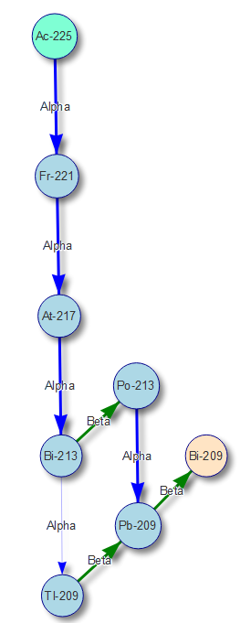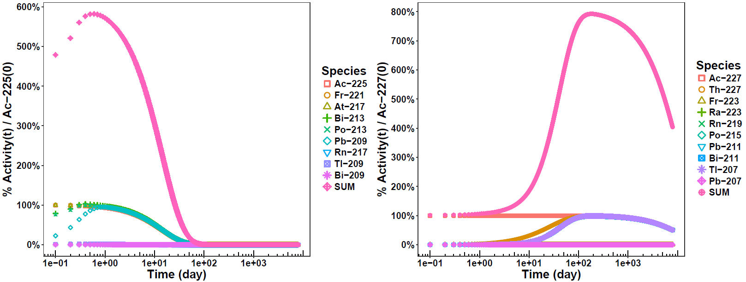

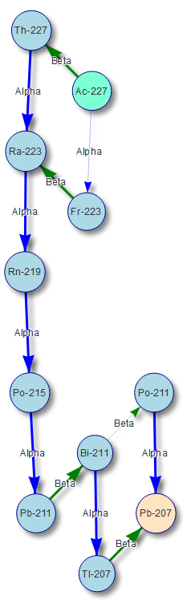 

**Figure 1.** Comparison of **A)** Ac-225 and **B)** Ac-227 decay. **Left:** Vertical placement is in relation to proton count. Parent is in teal, final daughter is in salmon, intermediate species with >0.1% incidence are blue. Line thickness indicates probability (thicker is greater probability). **Right:** Species activity in relation to pure actinium parent at t=0 [% Activity of Species(t) / Ac-22X(0)]. SUM is total of all species.

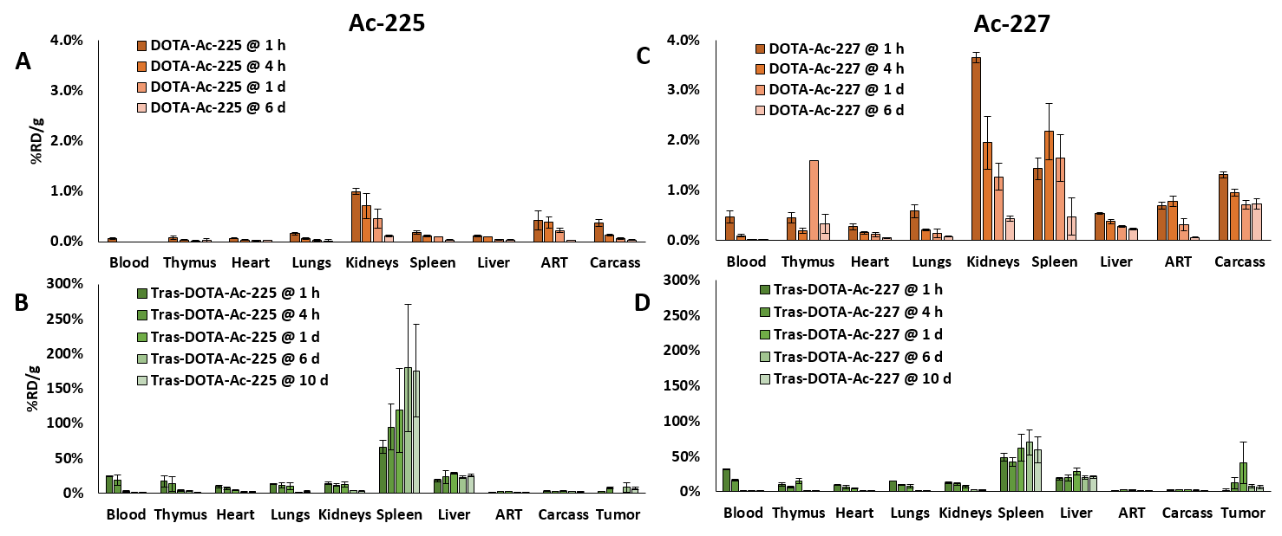

**Figure 2.** %Recovered dose per mass (%RD/g).

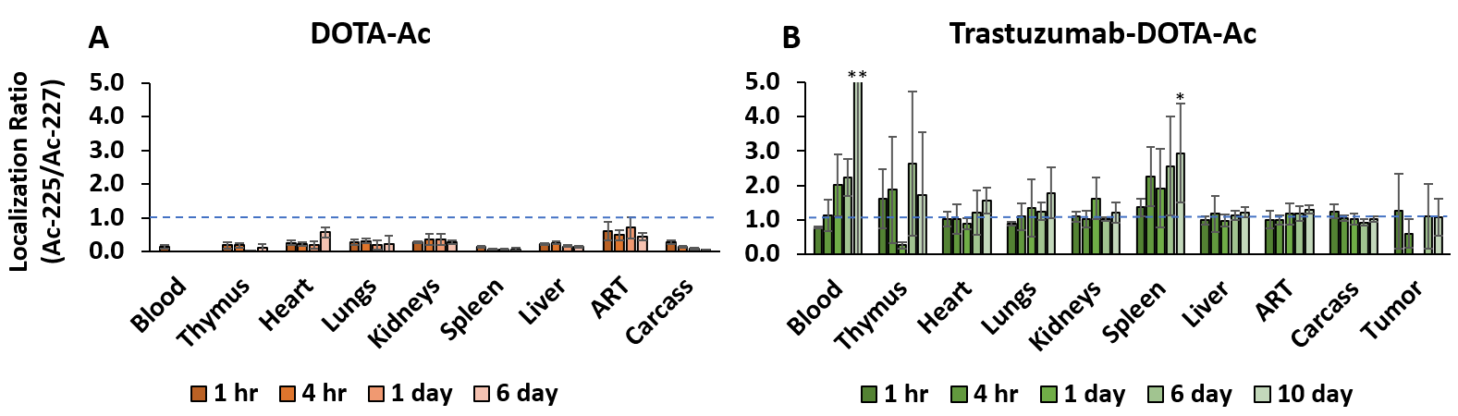

**Figure 3.** Localization ratio (recovered dose per mass of Ac-225/Ac-227). *P-value < 0.05. **value out-of-scale, mean 10.8 ± 19.0 SD.

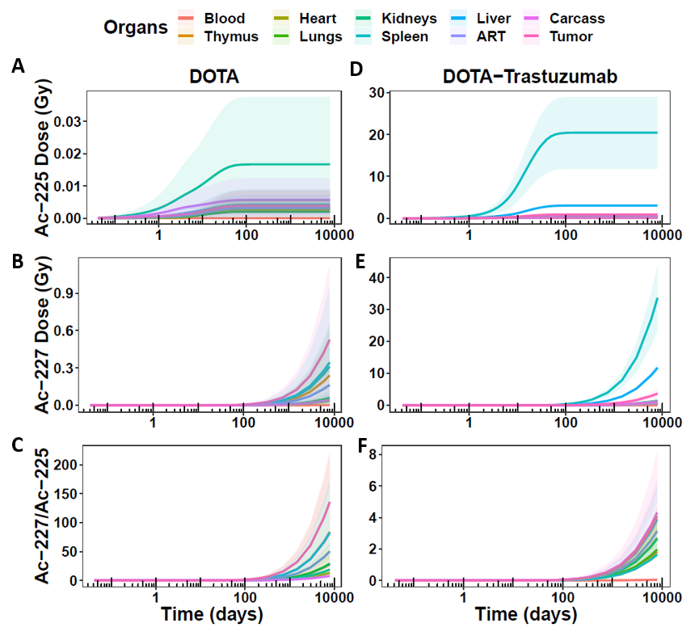

**Figure 4.** Cumulative dose over one Ac-227 half-life (7946 days).

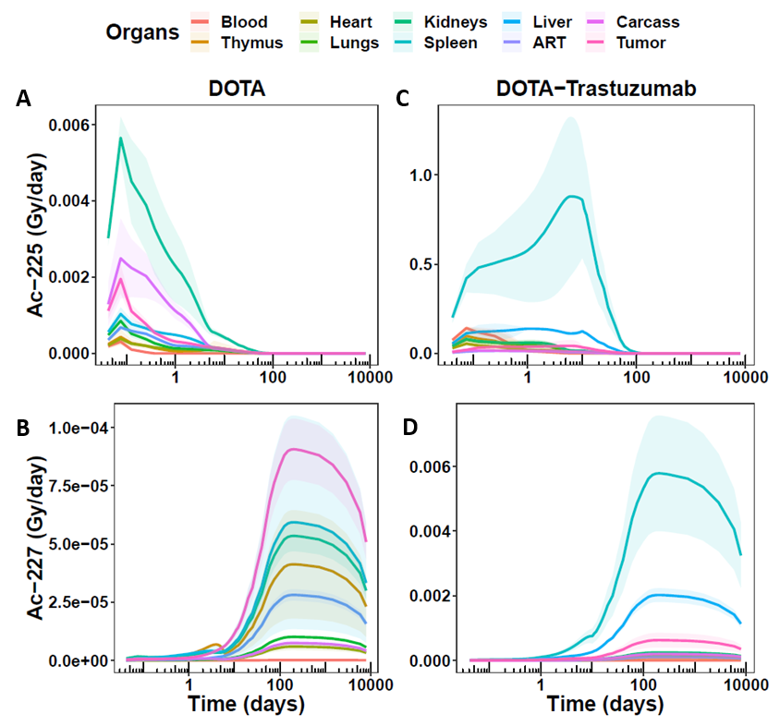

**Figure 5.** Dose per day over one Ac-227 half-life (7946 days).

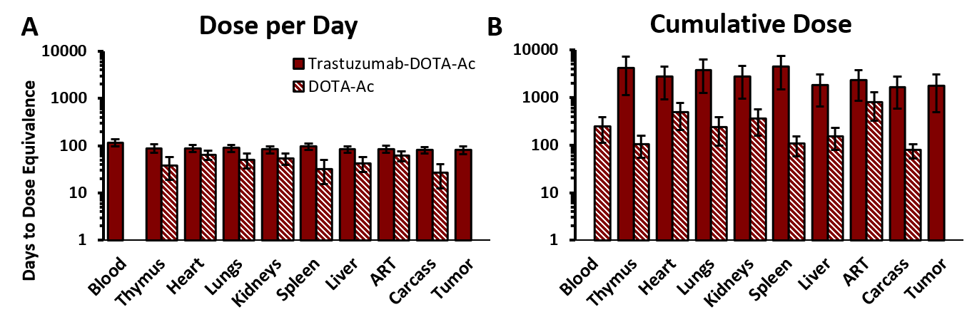

**Figure 6.** Number of days until dose equivalence between extrapolated Ac-227/Ac-225 dose ratios. In A), DOTA-Ac does not reach dose equivalence for the blood, and in B), Trastuzumab-DOTA-Ac does not reach dose equivalence for the blood.

**DISCLOSURE**

The authors have no disclosures.

**ACKNOWLEDGEMENTS**

This work was supported by

**SUPPLEMENTAL INFORMATION**

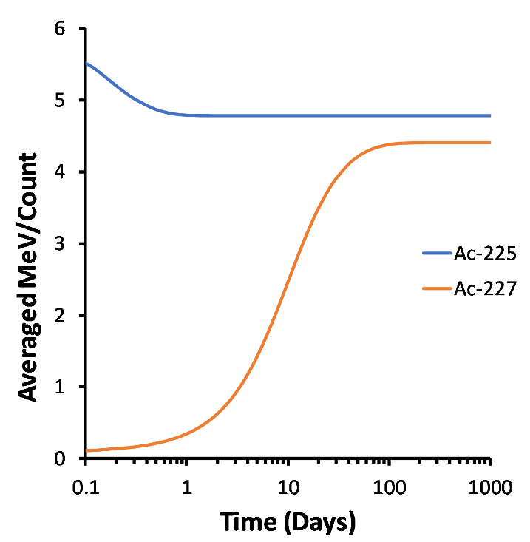

**Figure S1.** Starting with pure actinium species without daughters, equilibrium of average energy per destruction (counting both alpha *and* beta species) occurs rapidly within one day for Ac-225, and only after 100 days for Ac-227.

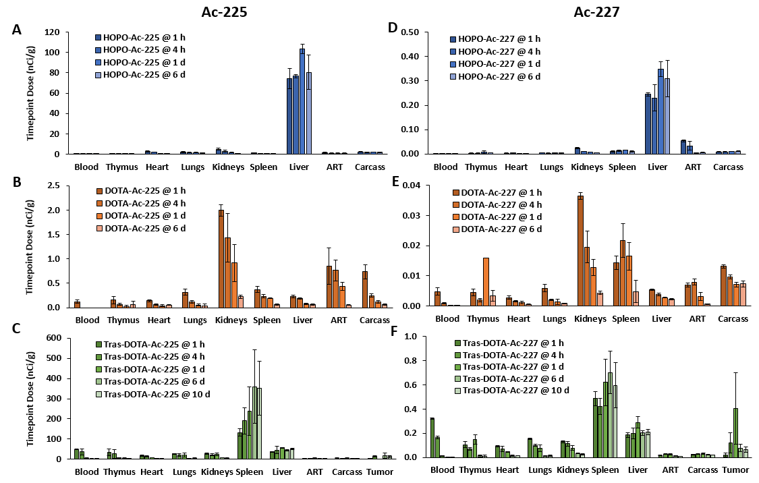

**Figure S2.** Dose biodistribution with exactly 200 nCi Ac-225 and 1 nCi Ac-227 per mouse, based on %RD/g plots in **Figure 2**.

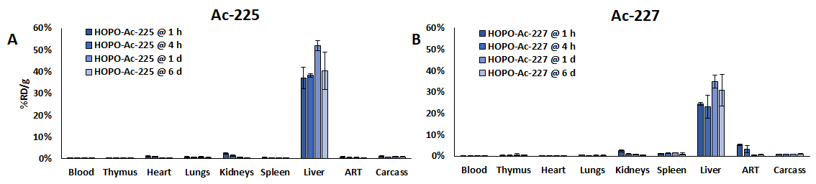

**Figure S3.** HOPO %RD/g. Considering the RD/g values from **Figure 2** are proportional to relative organ dose, HOPO showed greatest dose to the liver for both Ac-225 and Ac-227, with a cumulative Ac-225 mean dose of 4.26 Gy (95% CI 3.97-4.54 Gy) which remained steady after 125 days (A). HOPO-Ac-227 at 125 days showed an increasing mean dose of 0.323 Gy (95% CI 0.30-0.36 Gy), and after 7946 days, a mean of 22.4 Gy (95% CI 20.3-24.5 Gy) (B).

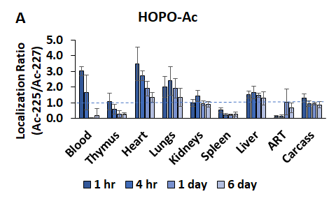

**Figure S4.** HOPO localization ratio.

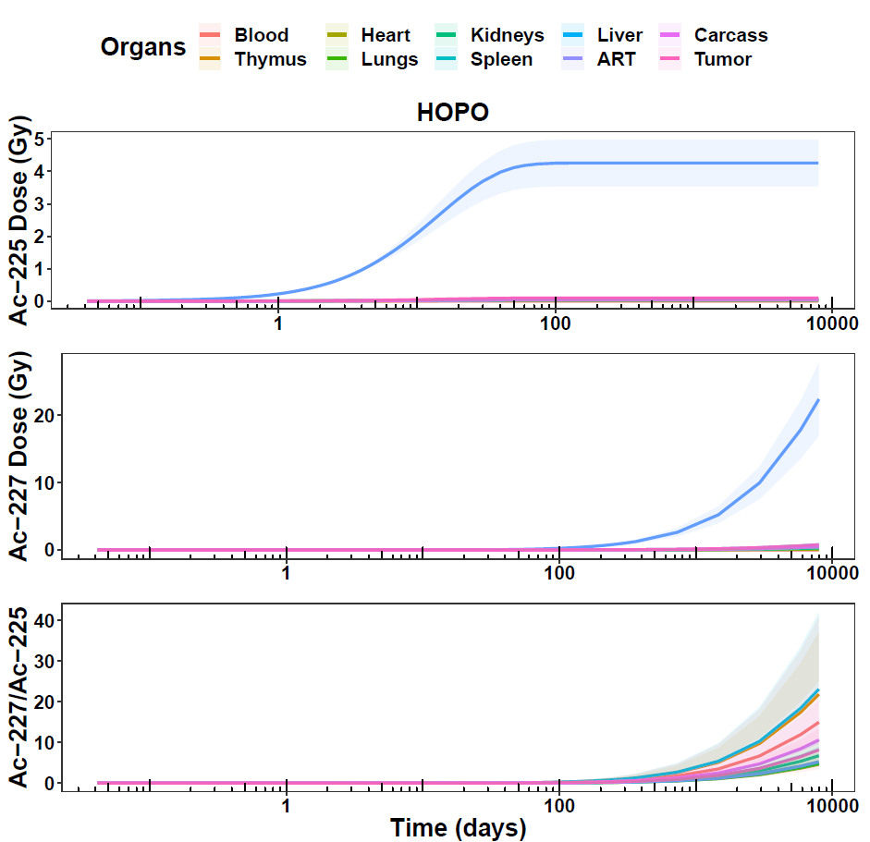

**A**

**B**

**C**

**Figure S5.** HOPO cumulative dose modeling. Due to the increasing values of Ac-227 cumulative dose, the dose ratios were initially small, and increased to a range of roughly 5-20 at 7946 days (C).

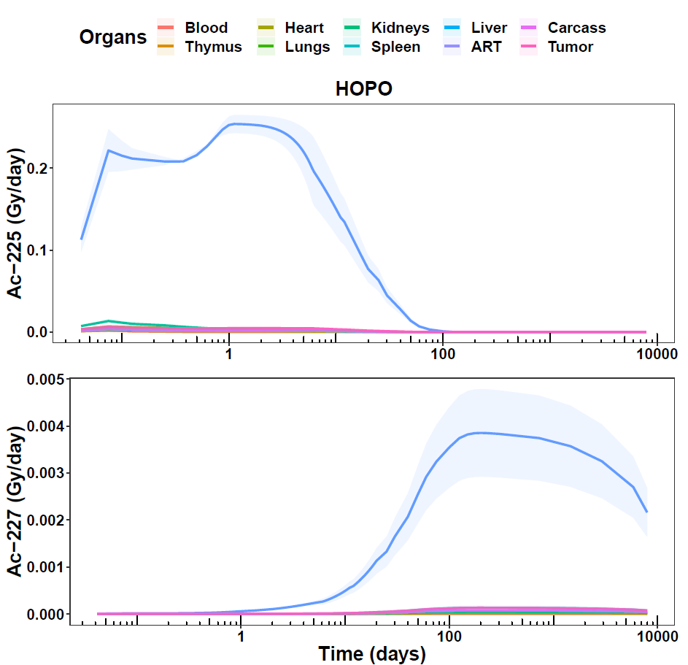

**A**

**B**

**Figure S6.** HOPO dose per day modeling. HOPO-Ac-225 showed a maximal mean of 0.254 Gy (95% CI 0.249-0.258) at 1.33 days (A) in the liver, whereas HOPO-Ac-227 showed a maximal mean of 0.039 Gy (95% CI 0.035-0.042) at 200 days in the liver and continued to decrease as Ac-227 decayed (B).

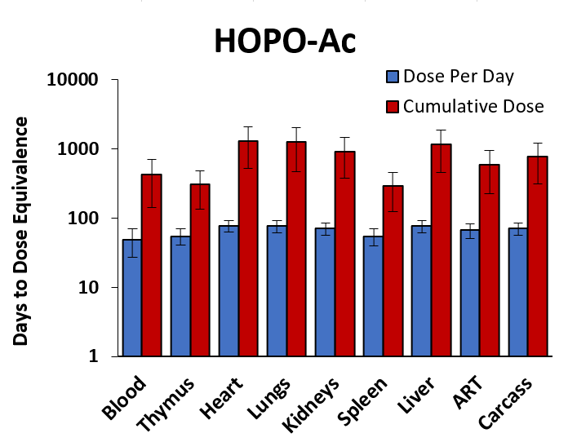

**Figure S7.** HOPO days until dose equivalence (Ac-227/Ac-225).

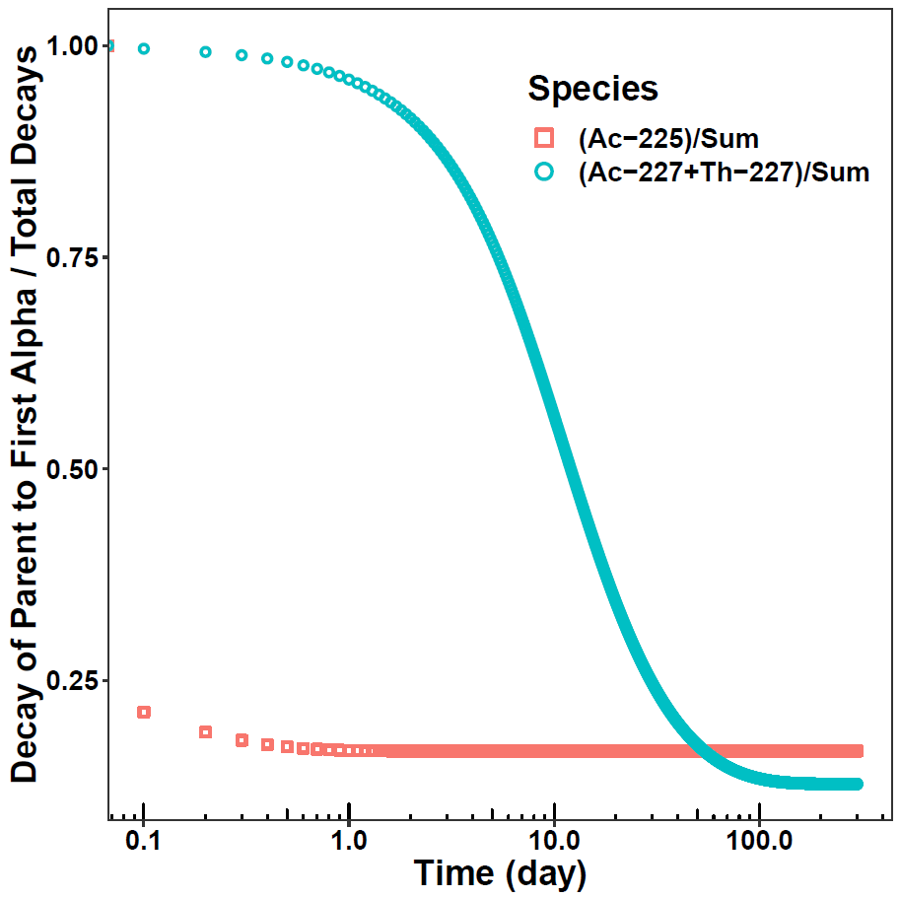

**Figure S8.** The ratio of

**A**

**B**

**C**

**D**

**E**

**F**

**G**

**H**

**I**

**A**

**B**

**C**

**D**

**E**

**F**